**Notes from FRA discussion on 18th Sept 2018**

Here are the notes from the discussion we had regarding the FRA software.

* First of all, we are unable to access test url properly as it has limitation of Sec-LAN network. Please provide the testing enrolment of SSOTEST so everything can be cross checked.
* There was an issue with the software in which the buttons were inactive at the normal font size and it would start working when we zoomed out. It needs fixing. This took a lot of time while we tried to check on multiple browsers and versions. More rigorous testing on multiple browsers and versions might help us catch such things faster. (**High Priority**)

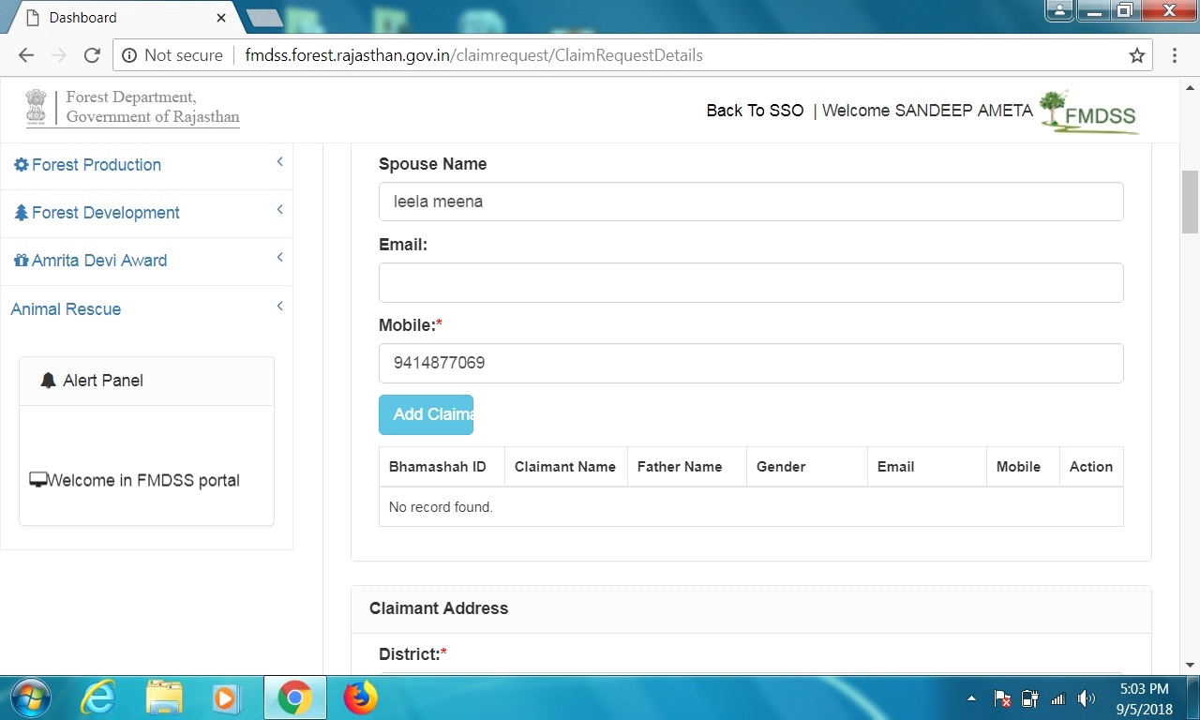

* This application also be in Hindi. We can think of whether this can be done now or after the launch. (High Priority)
* When we submit the claimant form to gramsabha and for other process the submit ID is Like I-29, I-27 so we need the proper ID. That we used for further. We suggest claim ID format like - **FRC-I/2017-18/453678 or FRC-C/2017-18/453678** (High Priority)

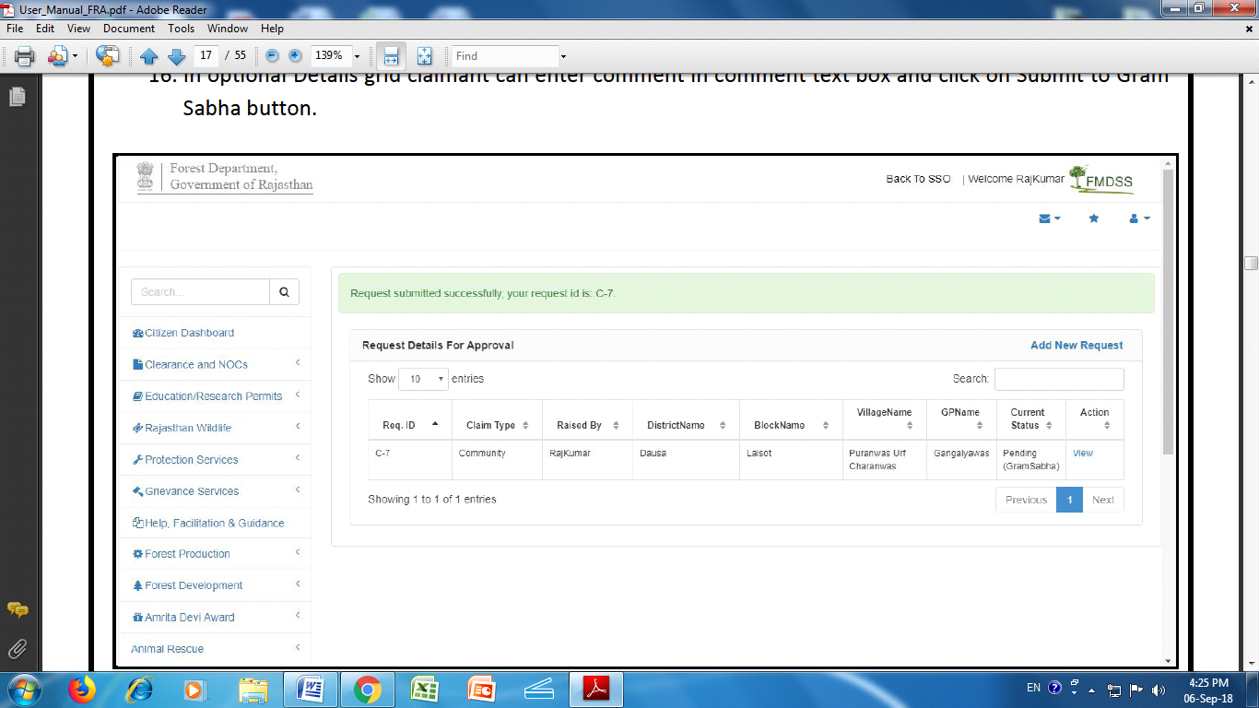

* Evidence list should have the following list in the same order. (High Priority)
* Public Documents: census, survey, ror, pattas, reports, orders, notifications, satellite imagery, forest enquiry reports, forest records, committee/commission reports etc.
* Records from princely states or other intermediaries.
* Statement of elders
* Voter Identity, Ration card, Passport, House tax receipt, domicile certificates, Electricity Bill.
* House, improvements to land.
* Judicial and quasi-judicial records including Courts orders and judgements.
* Research studies.
* Traditional structures: wells, burial grounds, scared places.
* Genealogy or recognition of residency at an earlier time.
* Other Document- FRA Sec-13
* गजेटियर, जनगणना सर्वेक्षण और बंदोबस्त रिपोर्ट मानचित्र , उपग्रहीय चित्र वन जांच रिपोर्टे , अन्य वन अभिलेख , पट्टा या लीज , सरकार द्वारा गठित समितियों और आयोगों की रिपोर्टो , सरकारी आदेश , अधिसूचनाएँ , परिपत्र , सरकारी अभिलेख ;
* अभिलेख , मानचित्र , अधिकारों का अभिलेख , विशेषाधिकार ;
* बुजुर्गो का कथन ;
* मतदाता पहचान पत्र , राशन कार्ड , पासपोर्ट , ग्रहकर रसीदें , मूल निवास प्रमाणपत्र , बिजली बिल ;
* गृह , झोपडी और भूमि में किए गए स्थायी सुधारों जैसे मेड बंदी;
* अर्धन्यायिक और न्यायिक अभिलेख ;
* अनुसन्धान अध्ययन ;
* कुँए , कब्रिस्तान , पवित्रस्थल ;
* वंशावली या पहले के समय निवास की मान्यता;
* अन्य - FRA नियम , 13 के अनुसार ;

1) Please make "BHAMASHAH ID" optional in the individual form.

2) In the individual form, please disable the radio button with the heading "Other Traditional Forest Dwellers", when radio button with heading "Scheduled Tribe" is marked as "Yes".

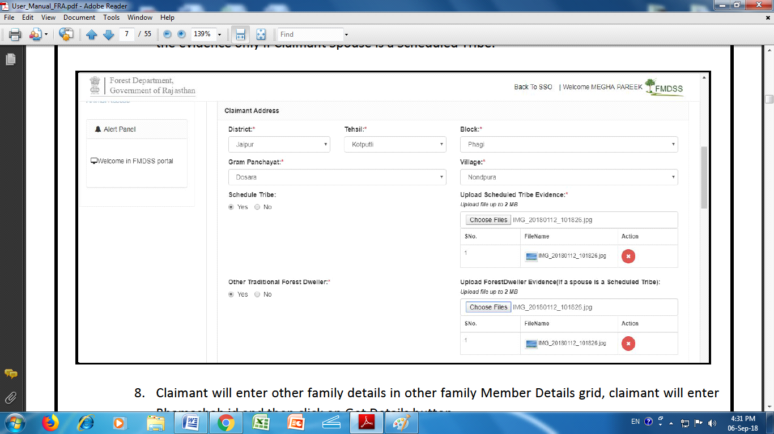

3) When "Bhamashah ID" is asked for in the individual form, please do not make it mandatory for the user.

4) In the individual form, the user should enter two options out of the mentioned nine options at then and there itself. (Attachments)

5) Please add receipt number in community form so that the user may be able to track the form at any point of time. This will be similar to all the other applications on the emitra system.

6) The Gramsabha login should allow entry of multiple applications on behalf of other users.

7) At each level, the pending applications in the level below should be seen. At this point, this visibility is only there at the district level login.